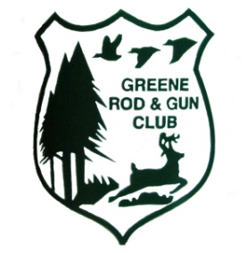
GREENE ROD & GUN CLUB, INC.
ESTABLISHED 1937 INCORPORATED 1948 607-656-8430 www.greenerodgun.com
P.O. box 315 Greene NY 13778. 365 Foster Hill Rd, Greene NY, 13778
NRA#R8322, EIN 16-1212967, NYS DOS #72029, NYSRPA 039737
GPS 42.3069, -75.8226., Tax Map 246.-3-22

2025 IDPA pistol match at Greene Rod and Gun Club
NRA Special Tournament
Number of shooters anticipated per match = 15 to 45
Important: Out of state shooters travelling in to New York with pistol and ammo ill need to print the NRA Sanctioned document to carry with them in case pulled over coming to match or pulled over going home. This is the primary reason to seek NRA Sanction

Monthly Tier 1 “third Saturday” dates.
2025: Mar 15, Apr 19, May 17, Jun 21, Jul 19, Aug 16, Sept 20, Oct 18, Nov 15

ALTERNATE: Monthly Tier 1 Rain/alternate dates. 4th Saturday.
2025: Mar 22, Apr 26, May 24, Jun 28, Jul 26, Aug 23, Sept 27, Oct 25, Nov 22

Tier 2 Bull Thistle match
Staff shoot Friday Aug 15th
Regular match date Saturday Aug 16th

To register and confirm dates, go to: https://practiscore.com/clubs/greene-rod-and-gun-club

