RBGC IDPA

New Shooter
Information Packet

April 2021

Last revision: 20210427

IDPA New Shooter Information
Last revision: 20210427 Page 2
Welcome to IDPA Competition!
IDPA shooting is a fun and safe way to learn defensive pistol skills and sharpen your gun handling and shooting abilities. IDPA’s safety rules are easy to learn and follow. Please read this material to familiarize yourself before your range safety orientation and participating in your first match.
The intent of this pamphlet is to give you a brief overview of IDPA and what you may expect when you shoot your first match at RBGC. It does not cover everything. For in-depth information, please visit IDPA on the web at www.idpa.com. The complete rule book is available on the IDPA web site at www.idpa.com/compete/rules.
Safety Rules
As with any firearm competition, safety is the primary and fundamental concern. The Four Rules of Gun Safety are the basis for the IDPA safety rules:
- Assume all guns are always loaded
- Never let your muzzle cover anything you are not willing to destroy
- Keep your finger off the trigger until your sights are on the target
- Know your target and what is behind it.
If these simple rules are always followed, most firearms accidents will never happen. Pay considerable attention to rules two and three. When shooting IDPA your finger should never be inside of the trigger guard until you are on target and ready to shoot. Always be aware of your muzzle’s direction and keep it pointed safely downrange. Muzzle Safe Points are the limits that a shooter’s muzzle can travel without being unsafe. Be sure to know where these limits are and always keep within them. Certain IDPA courses of fire may test your skills of keeping the muzzle in a safe direction. Be mindful of your muzzle and trigger finger, and you will always shoot safely.
Note that RBGC IDPA competitions take place on a “cold” range, so your firearm will never be loaded until you are told to load it by a Safety Officer. You may handle
ammunition and load your magazines at any time, but the firearm must always remain unloaded and holstered/cased unless instructed otherwise.
All ranges have a “safe area” where you may handle, lubricate, and maintain your firearm. The safe area may NOT have any ammunition present in it. In this safe area, you may transition your unloaded pistol from your range bag to your holster, unholster your unloaded pistol and perform any maintenance, practice drawing from the holster, or make holster adjustments. With the exception of temporarily using an empty magazine to decock your gun, at no other time are magazines allowed to be handled in the safe area.
Shooting Gear for the New IDPA Shooter
Last revision: 20210427 Page 3
Participation in IDPA matches requires the use of handguns, holsters and other equipment suitable for concealed carry self-defense. Additionally, pistol caliber carbine (PCC) long guns are allowed. With that in mind, and keeping the shooters' best interests in mind, IDPA's founders established equipment requirements that are based on commonly available firearms and gear, allowing individuals the opportunity to compete with minimal investment. The basic equipment requirements are:
- A safe handgun that is reasonable for self-defense
- A holster that carries the gun inside or outside the waistband on your shooting-hand side (no shoulder, cross-draw or tactical thigh-rig holsters). If you choose an Outside-the-Waistband (OWB) model, it must pull the gun tight to your body.
- Three / four magazines, or four speed loaders / moon clips
- Two magazine pouches (or a one double magazine pouch) or three speed loader/ moon clip pouches (BUG division is allowed three mag pouches on their person.)
- Eye and ear protection (safety glasses and a set of muffs or ear plugs)
- A concealment garment: jacket, vest, or shirt that can cover your holster and ammo carriers. On your first night shooting, you may be asked to not use a concealment garment.
- A good sturdy belt that will support the weight of your firearm and load devices and keeps your holster in a good upright position.
We recommend that you try the sport first, before going out and spending money on specialized equipment. Find out that you enjoy it, and what the experienced competitors use (and why they use it) before you make any investments in new equipment.
IDPA has seven different pistol divisions in which you can compete. Your firearm choice will determine which division(s) is applicable based on specifications listed in the IDPA rule book. We will not go into all the details here, so if you are unsure which is the proper division for you, ask when you come out to your first match and we can determine that then.
Ammunition
We recommend that you purchase basic ammunition for the matches. The accuracy and power of Match or Defensive-type ammunition is wasted on the type of shooting done at IDPA matches. For our club matches, you can generally plan on shooting between 150 and 200 rounds, so we recommend that you bring 250 rounds minimum in case a re-shoot is required.
What to Do On Arrival
Last revision: 20210427 Page 4
When you arrive at RBGC, you’ll need to register/check-in for the match. We will be using Cowboy Hill which is immediately to the right and up the hill as you enter the range.
- Registration will be setup in the clubhouse
Pay the match fee. It is $20 for non RBGC members and $15 for members.
- If this is your first time shooting at RBGC complete an RBGC Waiver form.
- New Shooter Orientation will start at 8:45 A.M.
- Group safety meeting will start at 9:00 A.M.
- Ensure that your gear (firearm, holster, mag holster, magazines, etc.) is ready for the
match
- Be prepared to start shooting the match.
- Wear Eye protection at all times.

Shooting the Match
Typical match will have stages setup in separate bays, with a warm-up stage on each bay. The starting bay for each squad will normally match the squad number, but may be changed by the MD and will be announced at the group safety meeting. Once the range is set we will call the range hot. At completion of shooting each stage, you are encouraged to observe the scoring of your targets. Once your targets have been scored, you will have plenty of time to reload your magazines/speed loaders. Everyone is encouraged to help paste targets and paint steel after they are scored.
The Basics of Shooting a Match
Now we get to the fun part, actually shooting the match. To safely shoot the match, IDPA uses a standard set of range commands. All actions on the range are controlled by a Safety Officer (SO). S/he will start out with the following commands:
Range is Hot, Eyes and Ears – if you do not already have your hearing and eye protection in place, now is the time to do so.
Load and Make Ready – When it is your turn to start shooting the match, slowly draw your unloaded firearm, insert a loaded magazine, rack the slide to chamber a round and re-holster; or using a speed loader, load the cylinder of your revolver, close the cylinder and re-holster. Once you have holstered your firearm, do NOT remove it until instructed to do so by the SO. Most IDPA courses of fire require the gun be fully loaded (a full magazine [to division capacity] plus one round in the chamber). Each division has different capacity requirements on what is considered a "full" magazine. It is governed by the division in which you are shooting, not what your total magazine capacity is. If you are in doubt, ask what the magazine capacity is for your division. If shooting PCC, you will load and make ready at the first shooting position of each stage.

Are you Ready? – Once you are loaded and at the start position for the stage, the SO will ask "Is the Shooter ready?" We are looking for either a verbal or obvious nodding of the head that you are ready. If there is no response from the shooter within approximately three (3) seconds, the shooter is assumed to be ready. If you are not ready, you should make sure that the SO is aware of that by stating: “Not ready.”
Last revision: 20210427 Page 5
Standby - This command is given after the shooter is ready. This command will be followed by the start signal (clock buzzer) within one (1) to four (4) seconds. The shooter may not move or change positions between the “Standby” command and the start signal, unless required to do so by the course of fire. Once the buzzer sounds, you draw your firearm and execute the actions necessary to complete the stage.
If Finished, Unload and Show Clear - This command will be issued when the shooter has apparently finished shooting the stage. If the shooter is not finished, the shooter should finish the stage and the command will be repeated. To unload and show clear: remove the magazine and pull the slide back to show the SO an empty chamber. If using a revolver, open the cylinder and empty it.
If Clear, Slide Forward or Close Cylinder – Close the slide or the cylinder as appropriate. If shooting PCC, insert Empty Chamber Indicator (ECI) and close the bolt on the ECI.
Pull The Trigger - The shooter will point the semi-auto firearm at the backstop and pull the trigger to further verify that the chamber is clear. This requirement also applies to firearms with a de-cocker or magazine disconnect. For firearms with a magazine disconnect an empty magazine or dummy magazine must be inserted before the trigger is pulled, and then removed again. This command is not needed for revolvers or for PCC rifles with ECIs.
Holster - The shooter will safely and slowly holster the firearm. If shooting PCC, re-case or re-rack the rifle. With flag in place, keep muzzle pointed straight up when walking off stage.
Range Is Clear - This command indicates to the shooter and anyone within the stage boundaries that the range is clear. This command begins the scoring and resetting of the stage.
NOTE
When going through the steps above, wait for the SO's command for each step. If you get ahead of the SO and they do not witness every step, you will get to go through the process again.
Additional Commands
Some additional commands that you might hear during a match are:
Finger - This command is given when the shooter’s finger is not obviously and visibly outside the trigger guard when it should be, which is basically any time you are not actively engaged in shooting. A finger call is a procedural penalty and a second occurrence during a match is an automatic match disqualification.

Muzzle - This command is given when the muzzle of the shooter’s firearm is pointed near a muzzle safe point. The shooter must correct the errant muzzle direction and continue with the stage. Breaking the muzzle safe point is a serious safety offense and will result in a match disqualification. Different ranges have different muzzle safe points depending on their setup. At SSUSA, we use the 180 rule. Anytime your firearm’s muzzle breaks the 180 degree mark in relation to the backstop, you have broken the muzzle safe point which is an automatic match disqualification.
Last revision: 20210427 Page 6
Stop - This command is given when something unsafe has happened or is about to happen during a stage, or when something in the stage is not correct. The shooter must immediately stop all movement, place the trigger finger obviously and visibly outside the trigger guard, point firearm down range and at berm and await further instruction.
Safety Note
The three most important commands are: Finger, Muzzle, and Stop.
You must respond to these commands immediately.
Scoring – Once your firearm is safely holstered/cased/racked it is time to score the stage. Scoring is relatively simple. After you finish shooting, your raw time (time it took to shoot the stage) is recorded. Hits on the targets are scored as follows:
- All head (4”center) and 8" center mass ring hits are scored as 0 points down.
- Hits in the next scoring zone receive 1 point down each.
- Hits in the last scoring zone receive 3 points down each.
- Complete misses of the target are scored 5 points down each. (A mandatory head shot
that lands in the body is considered a miss. Also a mandatory body shot that hits the head is also considered a miss). Additionally, hits in hard cover (black painted portions of a target) are considered a miss. These points down are totaled up and multiplied by 1 second. That total is then added to your raw time which becomes your total time for that stage.
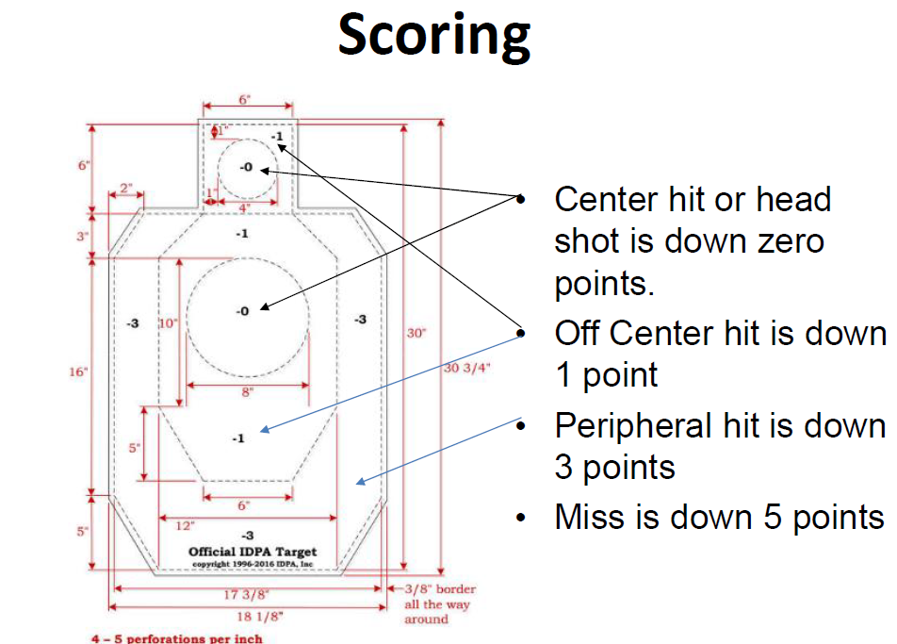

Penalties – Are earned/awarded for various rule infractions. The penalties are:
Procedural – Adds 3 seconds to the shooter’s score. Examples include (not all inclusive):
- Not engaging targets in proper sequence (near to far/slicing the pie)
- Not using cover properly/crossing a fault line while shooting
- Not starting with the required amount of ammunition
- Finger call (moving with your finger inside the trigger guard, but not engaging targets)
- Not fully engaging all targets (not firing all required rounds per target)
- Not following other course of fire rules as described.
Hit on a Non-Threat (NT) – Each hit on NT will add 5 seconds to the shooter’s score penalty.
Flagrant Penalty – Given when the shooter does not follow the course of fire and gains a competitive advantage. Each FP adds 10 seconds to the shooter’s score.

Failure to Do Right – This is a seldom-issued penalty given to shooters who do not follow the spirit or rationale of a stage. Equate an FTDR as unsportsmanlike conduct. It can also be issued for using illegal equipment. If you shoot the course of fire as outlined and do not try to use inappropriate techniques or equipment to gain an advantage, this will never be a problem. An FTDR adds 20 seconds to the shooter’s score.
Last revision: 20210427 Page 7
If you wind up earning a Procedural, Non-Threat hit, or Flagrant Penalty, do not get upset. This sport is all about learning and the only one who will remember at the next match is you. Learn from your mistakes and have fun!
The raw time, points downs, and penalties are added together yielding your final stage score. All the stage scores are added together to provide your match score.
Other Items of Note
Movement – There are times within a match that you will be moving from one shooting position to another. During these times the important things to remember are to keep your muzzle pointed downrange and keep your finger off the trigger and outside the trigger guard.
Other times you may be shooting while you are moving. The key to shooting on the move is to move smoothly by keeping your knees bent and placing one foot in front of the other (“heel to toe” or “toe to heel”, if retreating). Remember to get a smooth trigger pull on every shot. Your sights will move around some, but unless you jerk the trigger, you can still obtain decent hits.
Engaging Targets – All targets must be engaged in tactical priority, including all targets engaged “in the open.”
Tactical Priority is method of target engagement in which targets are engaged by their order of threat. Threat is based on the distance of the visible threats from the shooter. Targets are considered equal threat when the difference in the target distances to the shooter is less than 2 yards.
If several targets are visible at the same time, targets are engaged from near-to-far unless they are equal threat.
If targets are hidden by cover, the targets are engaged as they become visible around the edge of cover (slicing the pie).
A target is considered “Engaged” when:
- A cardboard target is deemed to have been engaged when the required number of shots for that target has been fired at the target.
- Body and head shots may be required on an individual visible cardboard target and must be shot in the order and quantity stipulated in the CoF. Failure to shoot one or more targets in the required body then head order earns the shooter a single PE.
- A reactive target is deemed to have been engaged when a minimum of 1 round is fired at the target, regardless of whether the target reacts. All penalties apply if the shooter does not re-engage the target until the target reacts or if the shooter unsuccessfully challenges
the reactive target calibration.
- A cardboard target with a steel activator behind it is considered engaged when the required numbers of shots are fired at the cardboard target.
When an activator reveals a target of equal or higher Tactical Priority, the shooter may interrupt the engagement of the cardboard target to engage the target of equal or higher Tactical Priority without retreating.
Target engagement penalties shall not apply in the following cases:
- A shooter may not be penalized for failing to fire the required number of shots at a disappearing target.
- When engaging a target array of equal priority, the shooter may not be penalized based on the shooter’s order of target engagement.
- Targets may be re-engaged from other shooting positions provided that it is safe to do so and the shooter does not break the defined muzzle safe points.
Reloads – There are 2 approved IDPA reloads:
Slide Lock/Empty Cylinder Reload – Your firearm is empty of all ammunition. You can drop the empty magazine/empty the cylinder, reload a fresh mag or speed loader/moon clip and continue.
Loaded Cylinder/Loaded Chamber Reload (also known as a "speed reload") – where there is ammunition left in the magazine / cylinder or in the chamber. When this is the case, the shooter must retain the magazine / live ammo on their person as part of the reload.
A reload is deemed initiated by performing any one of the following actions:
- Withdrawing a magazine, speed loader/moon clip from a carrier, pocket or waistband. - Activating the magazine release on a semi-auto pistol (as evidenced by the magazine falling from the firearm)
- Opening the cylinder of a revolver.
A firearm is deemed reloaded when the magazine is fully seated and the slide is fully forward or the revolver cylinder is closed and the firearm contains at least one unfired cartridge in the chamber, magazine, or cylinder.
Last revision: 20210427 Page 8
Malfunctions - If your firearm fails to fire, do not panic. Malfunctions happen and competition is an excellent place to learn how to perform recovery procedures quickly.
Keep the muzzle pointed downrange. Keep your finger outside the trigger guard. Most of the time, the problem is due to a bad round or improperly seated magazine. In this case: Tap the bottom of the magazine upward into the gun to re- seat the magazine, rack the slide back to chamber a new round, and then pull the trigger to verify that the gun will now fire. This is known as the Tap-Rack-Bang method. If a Tap-Rack-Bang does not work and you are not sure how to proceed, it is best to stop and request help from the SO. If requesting help, keep your muzzle downrange and follow the SO’s instructions.

A potentially dangerous malfunction is known as a squib. This is caused by a cartridge that has a primer, but no powder in the case. When a squib round is fired, the bullet is pushed into the barrel where it stops. Firing a subsequent round may cause the barrel to rupture, resulting in extreme damage to the gun and possibly the shooter. A squib can be identified audibly by the “pop” or “pfft” noise and by the distinctly reduced recoil. If you even suspect that this has happened, stop immediately and request help from the SO. Remember to keep the muzzle downrange and follow the SO’s commands precisely.
If you experience any kind of malfunction and are in doubt as to how to fix the problem, stop and ask the Safety Officer for help. Better to have a bad score than having to replace a damaged gun, or worse, damaged hands or face.
Final Tips
This sport rewards speed, but punishes for lack of accuracy. Take the time to place your shots properly. Remember you will lose one (1) second for each point down. This adds up more quickly than you would think.
Do not crowd the barricade or wall when using cover. Staying back from the cover will not only make you less of a target (in the real world), but will help you move from target to target easier.
Remember to get a smooth trigger pull every time, even at the expense of the “perfect” sight picture. Slightly misaligned sights may cause you to be a couple of inches off your point of aim, but jerking the trigger can cause you to miss the target entirely.
The final thing to remember is to stay safe and to have fun.

Last revision: 20210427 Page 9

